**Report : Calculation of Added mass of a submerged body**

********

Under the guidance of Guidance of

***Mr. M Palaniappan***

Scientist-F

National Institute of Ocean Technology(NIOT), Chennai

By: Shivam Verma

3rd year Undergraduate student,

Ocean Engineering and Naval Architecture

Indian Institute of Technology(IIT), Kharagpur

Date : 21/10/20

**Contents**

1. Prelude
2. Gauss Divergence Theorem
3. Reynolds Transport Theorem
4. Hydrodynamic Forces
5. Force on a Moving Body in an Unbouned Fluid
6. Added Mass
7. Boundry Integral Equation
8. Computation in Python
9. Bibliography
10. **Prelude**

The fluid flow is assumed to be : irrotational and invicid. This two properties help us to model the fluid motion through **Potential Flow Theory**. Thus a flow can be represented as a superposition of sources, sinks, dipoles and vortices.

The velocity of the fluid particles can be represented as a gradient of some scalar field. The very fact that the fluid is irrotational, helps us to arrive on the conclusion, with the help of vector algebra(1), that the fluid can be represented as a gradient of some scalar field. In order to simplify the calculations, we dodge the petrifying yet the beautiful million dollar equation



The above set of equations are called **Navier Stokes Equations**. Equation 1,2,3 represent momentum conservation and the equation 4 represents the mass conservation. The above set of equations can help in modelling any fluid flow provided the required parameters, shear number of boundry conditions and mathematical tools are available at hand. However, these non-linear partial differential equations can only be solved using some numerical techniques as the known analytical techniques cannot handle these complex equations. The solutions are however greatly deviated from the actual flow phenomenon, due to cumulative errors of the applied numerical technique.

Here, however we are simplifying our problem by taking some assumptions coupled with some other equation, helps in arriving at equations which can we solved both analytically and numerically. The assumptions comprises the flow is steady (no variation with time), uniform (no variation with space), two dimensional flow (constant along the z-axis), incompressible (constant density), invicid and irrotational flow. As the result of following assumptions our final equations of interest are



Equations (5) represent the accelerations in the mentioned directions. Equation (6) will be evaluated further to arrive at a result which is the heart of the potential flow theory, the Laplace equation.



Equation (8) is called the **Laplace Equation.** The LHS of the equation (7) is called the **laplacian** **of a scalar value phi** at some point, It tells the relative distribution of phi values around this point. A negative value indicates that the phi value at that point is higher than the surrounding region and a positive value indicates that the phi value at that point is lower than the surrounding region. If it is zero, as in our case, it indicates the distribution is either same throughout or the distribution is balanced, i.e., half of the portion around the point is having higher values and half of the portion is having lower values than the point in consideration.

* 1. **Gauss Divergence Theorem**

The Gauss Divergence theorem relates the flux of a vector field through a closed surface to the divergence of the field in the volume enclosed.



* 1. **Renyolds Transport Theorem**

Reynolds transport theorem helps in transferring a control mass system into a control volume system.



 is the rate of change of the system’s extensive property N. For example, if

N = P, we obtain the rate of change of momentum.

 is the rate of change of amount of the property N in the control volume.

 is the rate at which property N is exiting the surface of the control

volume. The term ɳρV.dA computes the rate of mass transfer leaving

across control surface area element dA.

For example:



**2 Hydrodynamic Pressure Forces**

One of the primary reasons for studying the fluid motion past a body is our desire to predict the forces and moments on the body due to dynamic pressure of the fluid. Thus, we wish to consider the six components of the force and moment vectors, which are represented by the integrals of the pressure over the body surface, or



**3 Force on a Moving Body in an Unbounded Fluid**

Under pure translation, we get equation (14) on expanding equation (12)



Upon careful observation of ϕj , we can conclude that it tells the about the force in the ith direction, if the body is moving in the jth direction. Thus if the body is moving in the x direction and we are interested to know the force in the y direction, then equation (14) takes the form



An alternative form of equation (15) can be written as



On ignoring the higher order terms we finally get the equation (17). This is also call linearization.

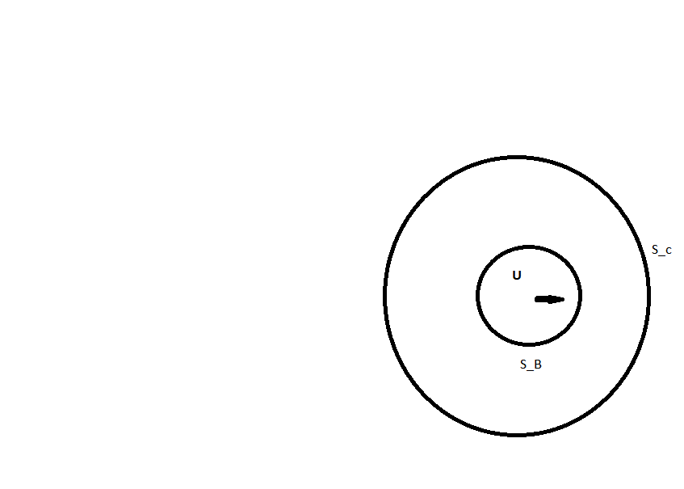





Suppose that the body has the translation velocity U, then the velocity must satisfy the following boundry condition



The boundry condition suggests that the total potential may be expressed as the sum





**4 Added Mass**

In order to understand the added mass qualitatively we can intuitively understand that any body/vessel that moves in any fluid say water, will continuously try to drag the fluid particularly under its boundry layer. This extra work done by the body onto the fluid is called the added mass effect of the body. Added mass is a common issue because the body and surrounding fluid cannot occupy the same physical space simultaneously. For simplicity this can be modeled as some volume of fluid moving with the object, though in reality "all" the fluid will be accelerated, to various degrees.the added mass is a second-order tensor, relating the fluid acceleration vector to the resulting force vector on the body

There are many methods to quantify the added mass. Here, I have used **Panel method** to calculate the added mass.

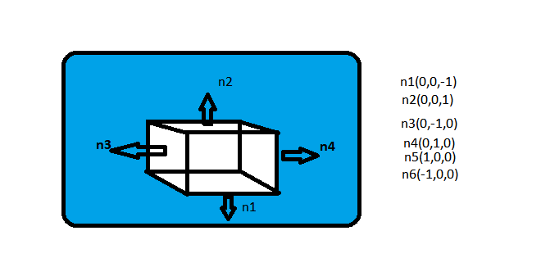

To numerically compute the added mass, I have used the **Boundry Element Integral Equation method**. The procedure is :

1. Formulate the Boundary value Problem ( for ϕ)
2. Find Proper Green’s Function
3. Derive the appropriate Integral Equation
4. Discretize the boundary by small segments called panels
5. Distribute ϕ over the boundary
6. Apply initial/boundary conditions
7. Convert Integral Equation into algebraic Equation in the form [A]{ϕ}={b}
8. Solve for ϕ

**4.1 Boundry Integral Equation**

Solution of Boundry Integral Equation gives the distribution of phi(s) across all the faces of the submerged body.is the potential of source point Q, located on the face. This ϕ(q) is used to calculate the added mass on the body, as well as forces on the body. This **ϕ(q)** is called the **Radiation Potential**.



is the potential of the field point P. If P is on the surface, value of  is 2п, if P is outside the body the value of is 4п and if P is inside the body then the value of  is 0.



To get the computable form of the equation (25) we proceed as



From equations (21 and 27) we get equation (25) as





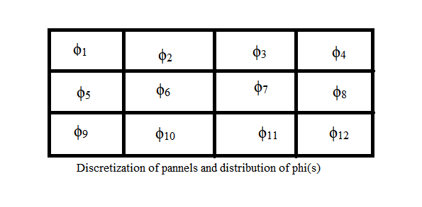

From equation (26) we can see that the field point is kept fixed and the source point moves.

In order to solve the equation (28) we assume that the field point is fixed on the 1st source point, i.e.,  and hence the value of is 2п. And r is taken out for all the moving source points() and fixed field points(). Then the 1st part of the RHS of equation (28) is assumed to be





Iterating on all the panels we end up with n number of equations, one corresponding to each panel. We arrange all the equations obtained as equations (29 and 39) into a matrix form. Thus the final matrix obtained is



We solve for matrix {ϕ}. Then this {ϕ} is used for evaluating the equation (24). We proceed as



**4.2 Computation in Python**

gg

**Bibliography**

1. Numerical Ship and Offshore Hydrodynamics Course,

Prof. Ranadev Datta

1. Marine Hydrodynamics, J. N. Newman
2. Wikipedia

**Thank you**